Slate App for Captains / Those Collecting Money

  - Log in to your Slate App using your email and password.
  - Click on the “View fixtures / events” button.
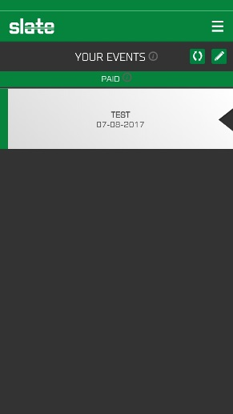
  - Select the pencil icon in the top right corner

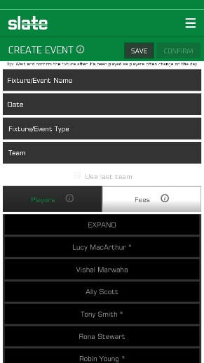
  - Enter the relevant details of the event
e.g. Home vs Glasgow Uni; 25/09/2017; Match fees; Ladies 2s
Select the players who played from the list by clicking on their names

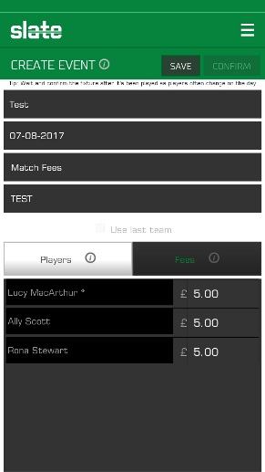
  - Click on the “Fees” tab to confirm the amounts owed per person, and to manually over-write this where required.

  - Select save, then confirm. When you press confirm you will receive an alert:
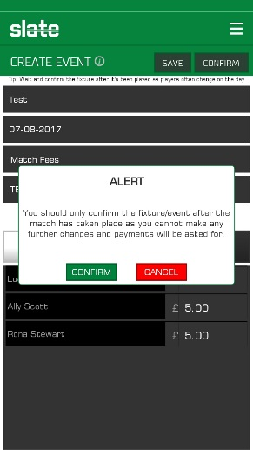
It is important that you do not press confirm until after the event (e.g. match) as when you do confirm the event, the amounts entered become due and the individual selected will receive email reminders until such a time as they pay the balance.

  - If you click on the event after you have confirmed, you will be able to identify who has and who has not paid the amount owed.

